Agenda for Today:
- Topics from Last Week
- Migration Summary
- Update on Automation
- Curtisswright.com
  - Walkthrough of Weekly Web Analytics of Curtisswright.com
    - Google Analytics: Link
Summary Report For Migration Websites (Batch 3):
Website | Owner | Completed Tasks | Upcoming Tasks | Clarifications/Requests
CW Phase 2.0 - Planning | Sai Krishna V | Received pptx file from Darren.  Had a detailed discussed with CW-Defense understood their requirements  We analyzed the requirement of CW-defense  CW Defense — DS Web 2.0 : Requirements via Implementation - 20 Topics - Internal (To be shared with Dave)  Based on Weekly Discussion with the defense team, we are working on migration planning on merging Curtisswright.com and CW defense.  We will look at all the schema, data objects, and forms and do a detailed technical analysis on the merger of these two sites (including conflicts, issues, and naming or taxonomy changes).  Defense Analysis :  CW Web2 - Migration_Plan - DS | Internally discussed the design standards.  Creating a Drupal theme (CSS, JS specific to 2.0 mockups) will be installed on the 2.0 development site.  (Figma > Drupal Theme)  ---  Approved Templates by End of March 2026  (After Exec Review, Dev Starts by April 7th 2026) | CW 2.0 Menu - Live Mockup : https://www.figma.com/proto/t7KTn7Ej7vEzlJymIsHYWE/Curtiss-Wright-Web-2.0?node-id=3272-3690&viewport=-33585%2C-860%2C0.35&t=22moO7kQjY1dhRgd-1&scaling=min-zoom&content-scaling=fixed&starting-point-node-id=3272%3A3690&page-id=2093%3A2  Acquia environment setup for CW phase 2 ✅  https://cw-2-0-sandbox.curtisswright.com/sensors  CW Theme 2.0 ✅ (theme name : cw_2, cw_2_sub)  Modules ✅  Design ☑️  Phase 2.0 - Homepage Design preview Curtiss-Wright Phase 2.0 - Home page.pdf  CW 2.0 Header Navigation UX process.pdf  Figma file link:  CW 2.0 Navigation changes - Option 1  Web Phase 2.0 _ Navigation Corporate + Division.pdf  Brand Guide is completed ☑️  Curtiss-Wright Design product pages Web 2.0.pdfCW Web-2.0 Style guide updated.pdf  Style Guide_abbreviated.pdf (CW Copy)  We have reviewed the CW Style Guide.
CW Phase 2.0 : CW Common Theme Development | Sunil Kumar Britto Raj | Created all Components ✅  - Completed Product and inner pages ✅  - Completed Home, Markets and Products Pages.  - All content is now editable using Layout Builder components.  - Completed the mapping of content types, site structure, navigation, Views, and the header and footer.  - Recreated the existing site using Layout Builder components.  - Login page designed. | - Working News and Events Page. | https://cw-2-0-sandbox.curtisswright.com/sensors  https://cw-2-0-sandbox.curtisswright.com/cw-2-0-components-home
Web refresh | Britto Raj Shilpa Patil Divya MSunil Kumar | EMS  Valves  Surface Tech  Nuclear  Sensors  Actuation  Curtiss-Wright | EMS - Completed and sent for review ✅  Valves - Completed and sent for review ✅  Surface Tech - Completed color refresh 2.0☑️  Sensors - Completed Color refresh 2.o ☑️  Nuclear - Header, footer, menu and copyright completed. Working on landing pages ☑️  Actuation -Completed Color refresh for 130/554 pages.☑️  CW- Started working on the staging site. | - Valves testing is completed.  - CWST testing is going on.  - Tentative Timeline : Nuclear by 4th September (delayed due to content change tasks).  - Testing will follow after 21st August for each of the sites.
Nuclear | Sunil | - Integrate ultra.energy (cwic.curtisswright.com)  - Integrate 3keysoft.com / ws-corp.com  - Integrate cw-connect.com  - Evaluate store.ultra.energy (cwicstore.curtsisswright.com) | WS-Corp Site Summary Document | It's on hold.
CWST Translation Sites/Content | https://surfacetechnologies.curtisswright.com/  Nihar / Sindhu | Completed the translations for the French, Polish, Spanish, Chinese, and German languages. ✅ | Phase 2.0:  We have started Hungarian translations for whole sites. ☑️  Completed Pages: 239/249. | Phase 2.0:  Working on the Hungarian translations for the whole site. ☑️  Complete the Hungarian language translations by EOD. Next week, we will start updating the links on each translated page. ☑️  Tentative timeline for link updation: 3rd week of September.
Searchstax | Rohan |  | A custom module is developed. ✅  https:/curtisswright.com/search | Analytics Report  Waiting for Dave’s response on ticket INC0227363 regarding the case-sensitive search issue.  We are adding a * wildcard to every search word to get more results. However, this is causing an issue when users search for iq-core, as it returns fewer results than IQ-Core.
SEO Optimisation for curtisswright.com | Sofia Krishnan | - Completed fixing duplicate titles for Surface tech ✅ | - Working on optimizing page meta titles, description for the Surface Tech site. (Ticket No :INC0224386) | Sofia is working on the SEO Analysis of CW Business Sites (We have completed Surface Tech earlier)
Everlube | Divya M | everlubeproducts.com | Everlube Site Summary Document | Evaluation of the site is completed and sent for review. ✅  No updates this week.
IMR test Labs  http://imrtest.com/ | Shilpa Patil | IMR Site Summary Document  Completed Layouts : 02/52  Completed Pages Migrated: 0/182 | Pending layouts: 50/52  Pending Pages : 182/182 | No updates this week  Migration will start after 2.0 web refresh.
Keronite | Britto Raj | keronite.com | keronite Site Summary Document | Evaluation of the site is completed and sent for review. ✅  No updates this week  Migration will start after 2.0 web refresh.
CWST - Searchable Approvals Database | Divya M | TG Approvals 2025 | Ref : https://www.valencesurfacetech.com/approvals/ | For Database Approvals -Waiting for Client Inputs. ✅  No updates this week

Summary Report For Live Websites :
Website | Open Items | Clarifications/Requests | Resolved Issues / New Updates
Curtisswright.com  https://curtisswright.com  Live ✅  Monitoring and Supporting. | No Open Issues |  | Content Updates on Curtisswright.com:  27 August 2026 - Weekly Content Summary
CWST  https://cwst.com  Live ✅  Monitoring and Supporting. | No Open Issues |  | No open items.
CW Sensors  https://cw-sensors.com  Live ✅  Monitoring and Supporting. | No Open Issues |  | No open items.
CW Industrial  https://cw-industrial.com  Live ✅  Monitoring and Supporting. | No Open Issues |  | No open items.
Sunrise PGDT  https://sunrise.pgdrivestechnology.com/  Live ✅  Monitoring and Supporting. | No Open Issues |  | No open items.
Support PGDT  https://industrial.curtisswright.com/en-gb/pgdt  Live ✅  Monitoring and Supporting. | No Open Issues |  | No open items.
SSRT  https://industrial.curtisswright.com/ssrt/user/login  Live ✅  Monitoring and Supporting. | No Open Issues |  | No open items.
Powerchair Manager  https://industrial.curtisswright.com/en-gb/powerchair-manager  Live ✅  Monitoring and Supporting. | No Open Issues |  | No open items.
CW Valves Group  https://valves.curtisswright.com/  Live ✅  Monitoring and Supporting. | No Open Issues |  | No open items.
CW EST  https://valves.curtisswright.com/en-us/EST  Live ✅  Monitoring and Supporting. | No Open Issues |  | No open items.
CW Nuclear  https://www.cwnuclear.com/  Live ✅  Monitoring and Supporting. | No Open Issues |  | No open items.
CW EMS  https://cw-ems.com/  Live ✅  Monitoring and Supporting. | No open issues |  | No open items.
CW Actuation  https://www.cw-actuation.com/  Live ✅  Monitoring and Supporting. | No open issues |  | No open items.
Sensors & Actuation  https://sensors-actuation.curtisswright.com/  Live ✅  Monitoring and Supporting. | No open issues |  | No open items.
CW Defense  https://www.curtisswrightds.com  Live ✅  Monitoring and Supporting. | No open issues |  | No open items.
CW Actuation Portal  https://portal.cw-actuation.com/  Live ✅  Monitoring and Supporting |  | Live: portal.cw-actuation.com | Learning management system (LMS) is completed and waiting for boonie’s feedback. ✅  LMS Training Portal - Feature Delivery & Task Tracker  Working on the Price Configurator frontend and backend to match the 3D PartCommunity Viewer design ☑️.  Also, showing the standard delivery option and price for each item in the selection dropdown. ✅  Removed consent to receive product update information from the user registration page ✅

Topics from Last Week
Topic | Details | Question/Clarification/Update
Few Low Priority Topics |  | CW September 2026 Events and PR ?
Bluefly Topics  Accessibility & SEO Improvements  Performance Optimization | Rasheed suggested CW SEO Topics and Scope. | CW <> Bluefly <> Etag - Topics Tracker  - Security and Drupal Core Updates ✅  - Autodiscover and missing blocks ☑️  - Working on Press release Date appending with title for all press releases on live site. (Completed year - 2002 to 2020) ☑️ - Will be continued after 2.0 web refresh  - Webform Module: The Counter Problem ☑️ (Testing few Drupal modules to implement Queuing process) - Will be continued after 2.0 web refresh
Service Now |  | Dev and stage url is unable to access.
Text Transform Capitalize |  | Header Section is completed for all the sites ✅
OKTA SSO Login | Created a ticket to whitelist the new Okta login URL | INC0231544

Analytics, Monsido, and Webmaster Console:

Analytics | https://analytics.google.com/analytics/web/#/p432579895/reports/intelligenthome
Webmasters Console | https://search.google.com/search-console?utm_source=about-page&resource_id=sc-domain:curtisswright.com
Monsido (Acquia Optimize) | https://new.monsido.com/

Analytics
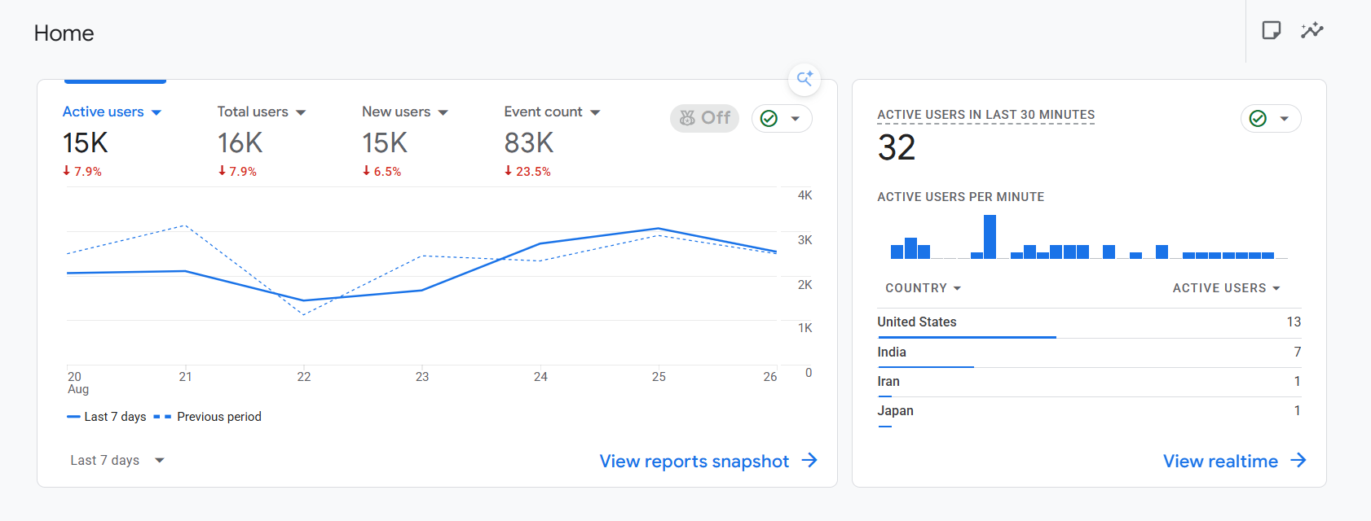
Monsido

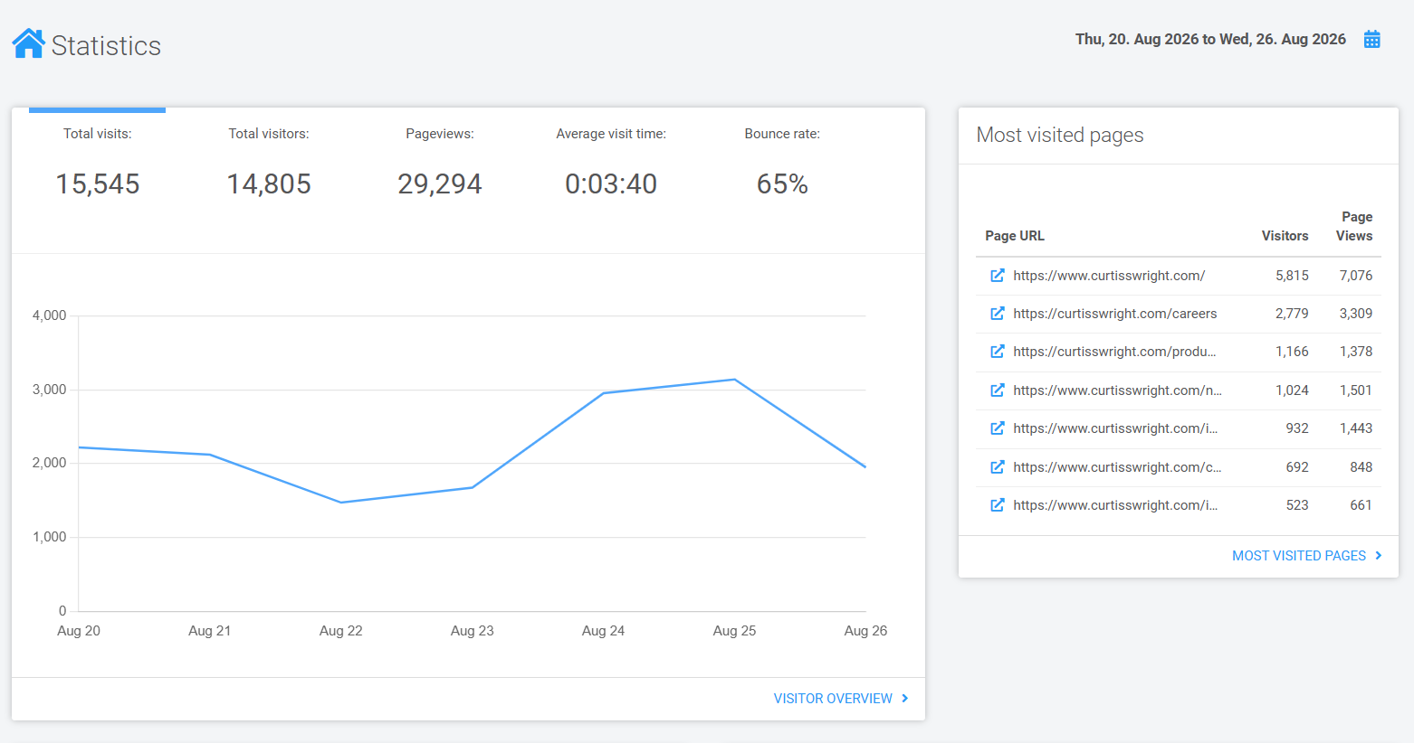

Search Stax
All Application
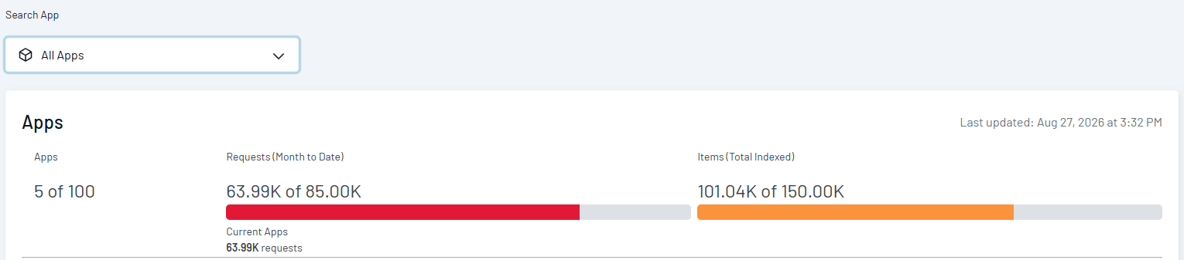
CW Live
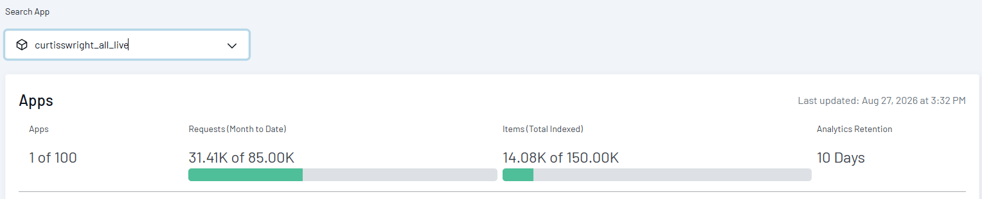
Inside CW Prod
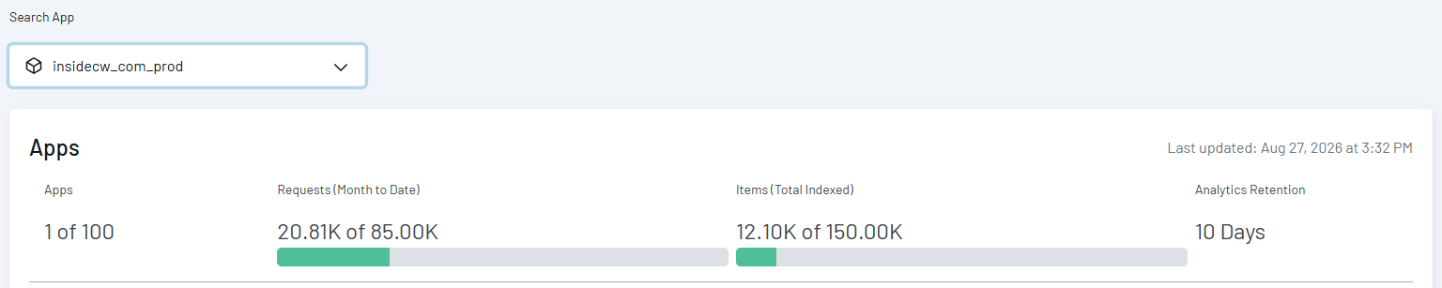

Dave’s priority list 2025

Topics | Owner | Status
Corporate - Add Veterans section to Careers | Divya M | Work in Progress
Global Search / Global Navigation | Sunil KumarRohan Gurav | - All the sites are now live with the SearchStax custom module implemented. ✅
Valves consolidation go-live | Divya MShilpa Patil | Went live ✅
Migration of cw-ssrt.com and powerchair-manager.com from Dreamscape (deadline approaching based on hosting) | Shilpa Patil  Britto Raj | SSRT went live ✅  Powerchair manager went live✅
Non-time-sensitive content change requests |  | Actively managed till 4PM EST Every Business day
CWST translations | Sindhu NJ  Nihar Ranjan Nayak  Divya M | Working on Hungarian translations. ☑️
Actuation portal improvements  Migration of tools.exlar.com | Rohan Gurav | LMS  - Started working on LMS
Actuation translations | Sindhu NJ  Nihar Ranjan Nayak  Shilpa Patil | Translation is on hold.
Migration of 3keysoft.com | Sunil Kumar | Site Summary Document ✅  Waiting for the stakeholder’s response. As per our discussion, only 10 pages need to be added manually, so there is no need to start the migration now. Once they share the confirmation, we will start Migration.
Centralized ticketing system to allow routing content change requests for approval | Rohan Gurav | This feature is in the roadmap

